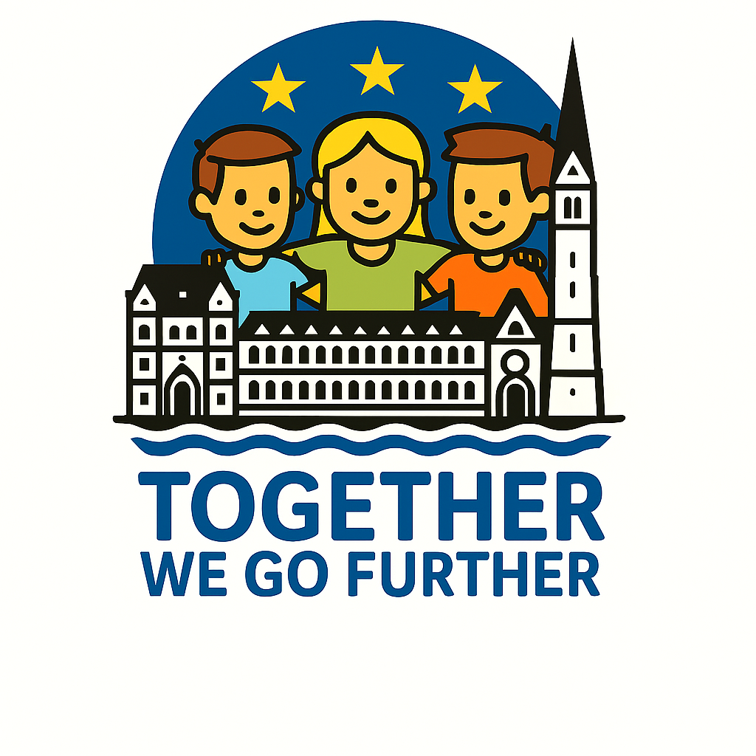

Ireland (created by Nikoletta Bakonyi)

Collection of online worksheets:

The Giant Causeway:

https://app.edcafe.ai/me/file?fId=691305ab3f466ccd26433110&from=library

Ireland – Culture Shock:

https://app.edcafe.ai/me/file?fId=6912ff373f466ccd26430c1f&from=library

